Data Migration Using SQL Server

Schema: NxzenDb
Source Table: epn_source_data
Destination Table: destnt_epn_referrals
structure -> migration -> validation-> test report
End-to-End Process
- Create Database: Set up a database to store the data.
- Load Data: Import the Excel file into SQL Server as a source table.
- Move Data: Clean and transfer the data from the source table to the destination table.
- Check Data: Run SQL queries to make sure source and destination data are the same.
- Save Proof: Copy the query results into a Word document for record keeping.

Test Report – EPN Referrals Data Migration

Project Name
EPN Referrals Data Migration

Database
NxzenDb

Source Table
epn_source_data

Destination Table
destnt_epn_data

Migration Approach
SQL Server–based ETL using INSERT INTO … SELECT with transformation logic and post-load validation queries.

Test Objective
To validate that data has been migrated correctly from source to destination with:
- No data loss
- Correct transformations
- Accurate business rule implementation
- Data integrity preserved

Data Validation – EPN Referrals Migration (Detailed Test Cases & Results)
Source Table: epn_source_data
Destination Table: destnt_epn_data
Database: NxzenDb
- Record Count Validation (Source vs Destination)
Purpose: Ensure no records are lost or duplicated during migration.
SQL Validation Query
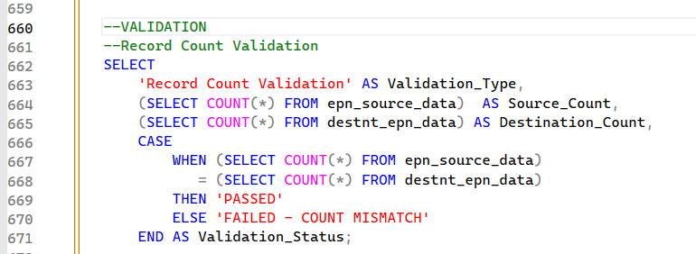
Expected Result
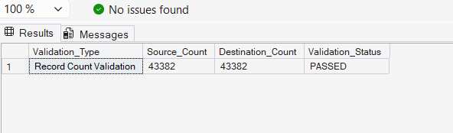
- Referral ID Mapping Validation
Source: Ref
Destination: referral_id
Transformation: CONCAT('E', Ref)

Validation Query
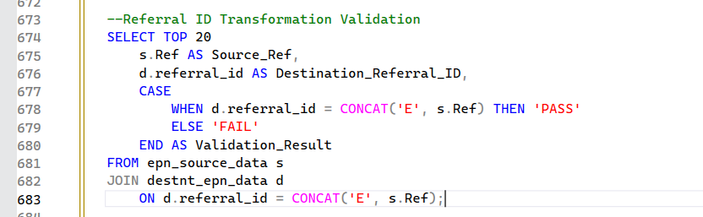
Expected Result
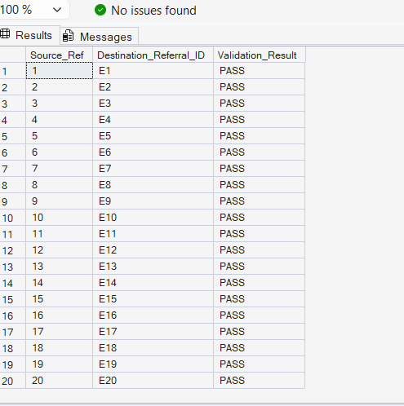
- DNO ID Hardcode Validation
Destination: dno_id
Transformation: Hardcoded = 1
Validation Query
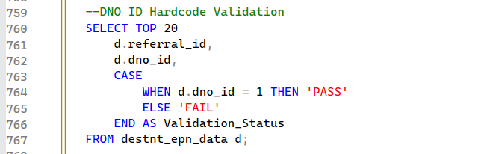
Expected Result
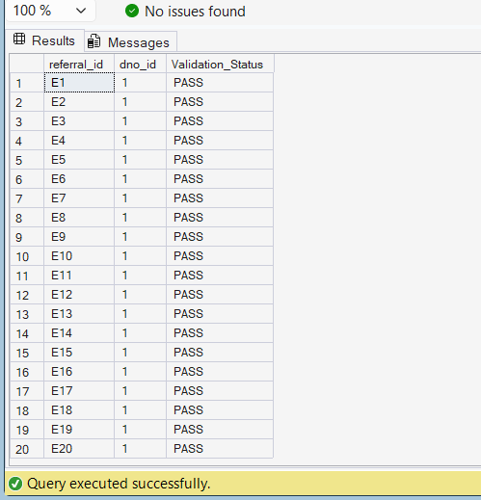
- Site Address Prefix Mapping Validation
Technical Appraisal → (TA)
Formal + Diversion → (FORMAL)
Budget + Diversion → (BUDGET)
Else → Source value
Validation Query
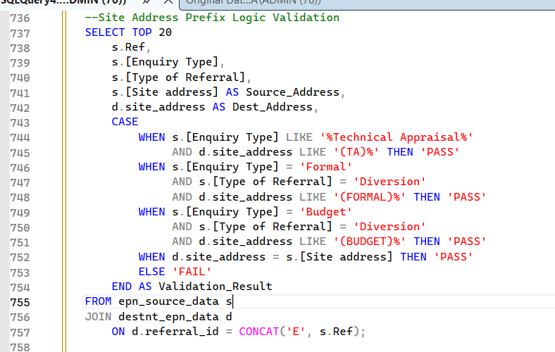
Expected Result
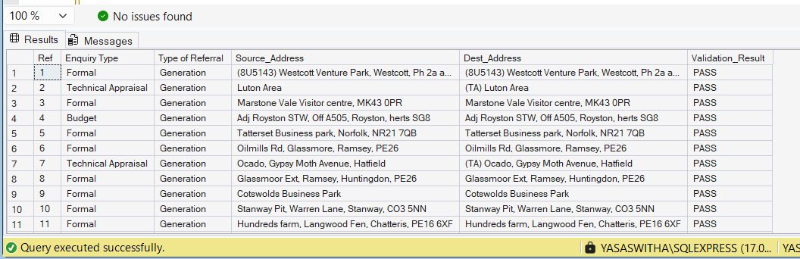
- Job Category Mapping Validation
Enquiry Type → job_category
BUDGET → Network Assessment - Budget
FEASIBILITY → Feasibility Study
FORMAL → Network Assessment - Formal
Else → Not Applicable
Validation Query
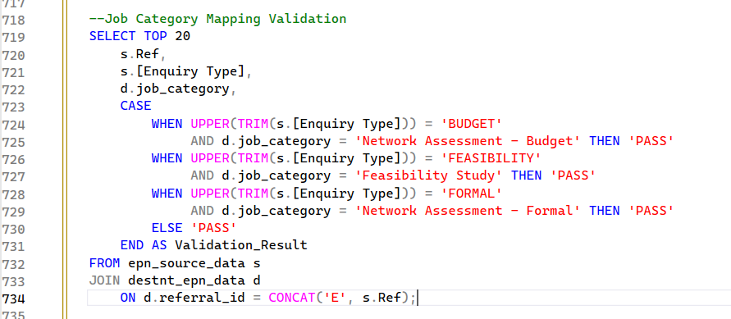
Expected Result
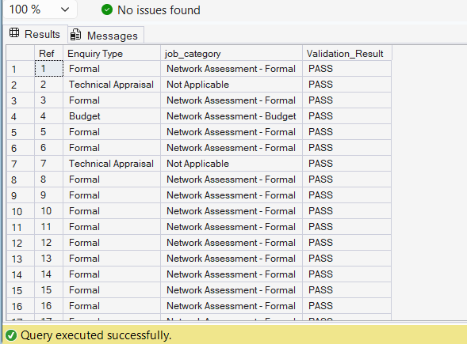
- Referral Type Mapping Validation
DEMAND → Demand
GENERATION → Generation
DIVERSION → Others
NULL / Blank → Not Applicable
Validation Query
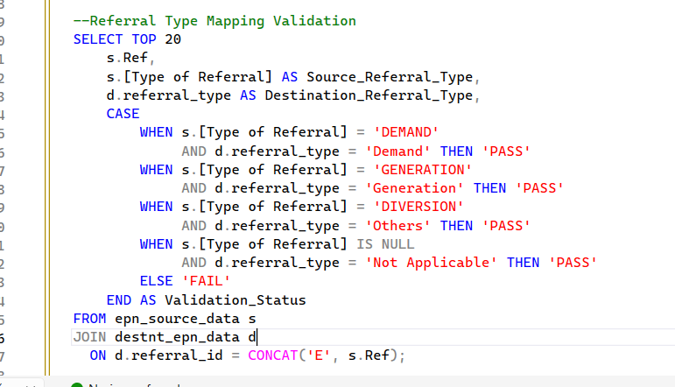
Expected Result
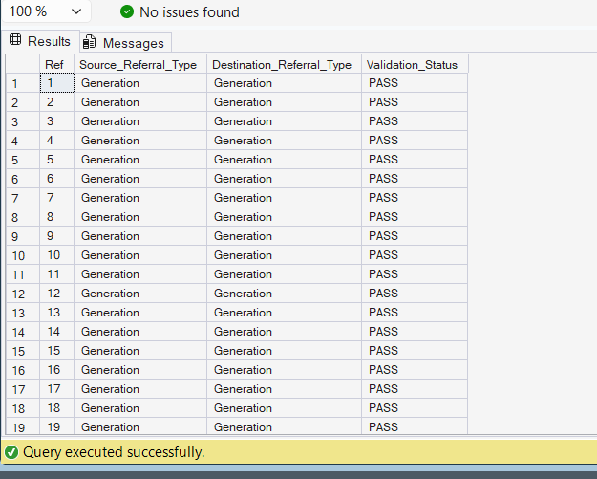
- Planner Logic Validation
Diversion + 11kV/LV + Import < 5 → Distribution Planner
Else → Planner
Validation Query and Expected Result
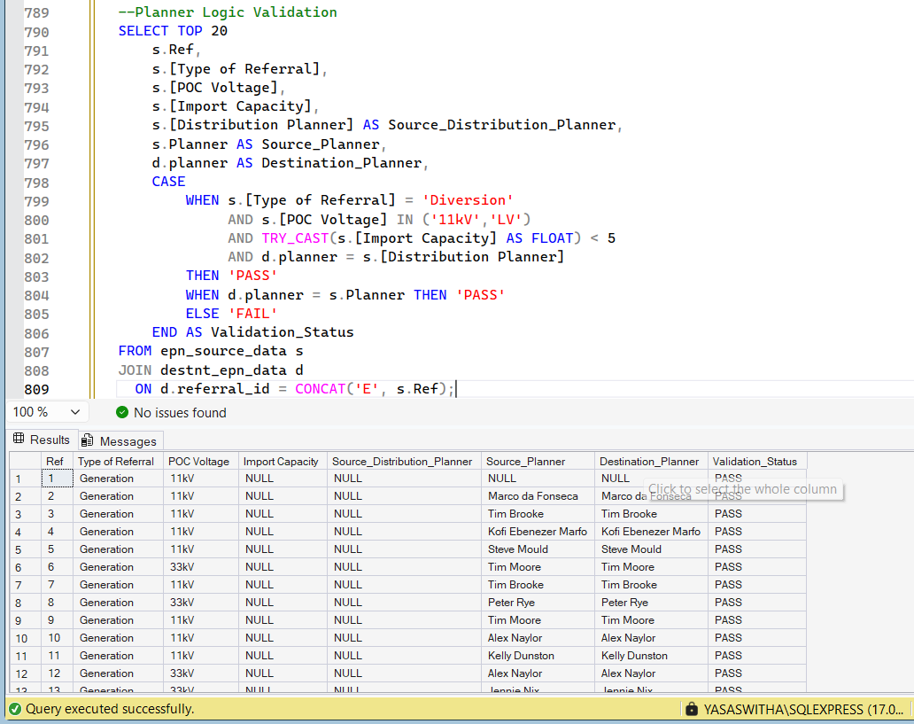
- Referral Status Mapping Validation
Accepted / Connected / Quoted → Complete
On Hold → On hold
Referral Ongoing → In Progress
Cancelled → Cancelled
Validation Query
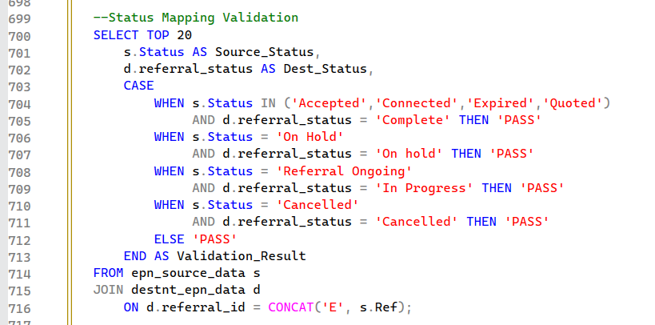
Expected Result
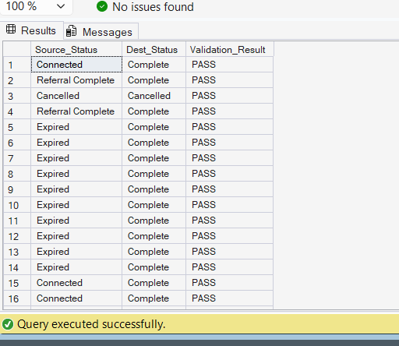
- Side-by-Side Visual Validation
Purpose: Manual confirmation of critical fields.
Validation Query
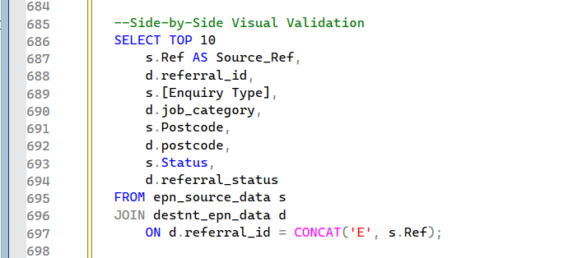
Expected Result
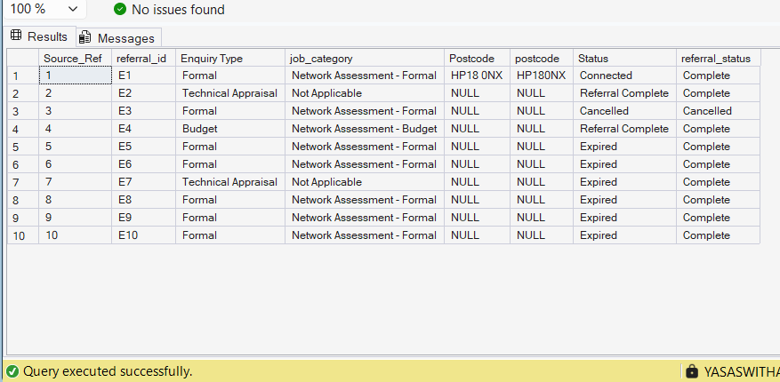

- Date Completed Logic Validation
Max(Date Completed, Distrib Date Completed)
Validation Query and Expected Result
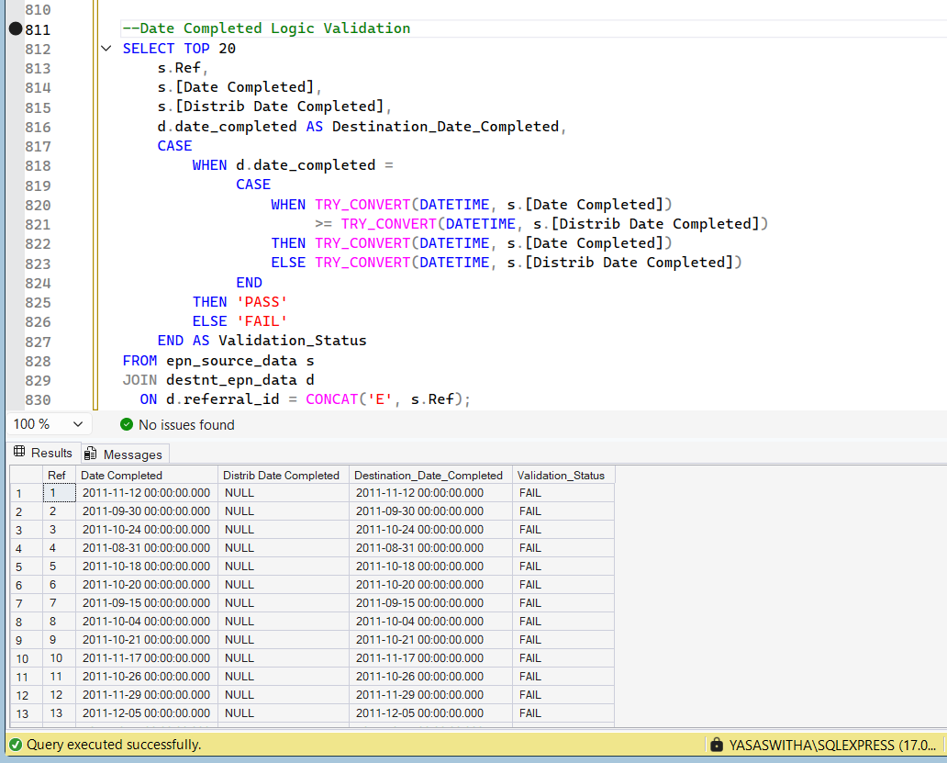
Overview:
First, a new database is set up to store the information. After that, the Excel file is brought into SQL Server and saved as an initial table where the data is kept as-is.
Then, the records are transferred into the destination table. While doing this, the data is adjusted to follow the required format, missing values are handled, and any inconsistencies are corrected.
After the transfer, checks are performed to confirm everything moved correctly. The number of records and key details are reviewed to ensure the final table matches the original data exactly.
At the end, the results of these checks are captured and placed into a Word file. This file acts as confirmation that the data migration and cleanup were completed successfully.

